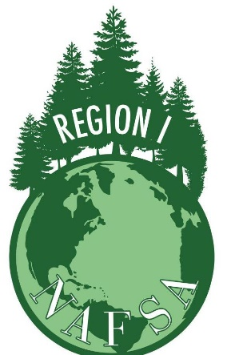

REGION I SILENT AUCTION DONATION FORM

Name of donor or company (as it should appear in auction listings):

Address:

Contact name:

Telephone number:

Fax number: E-mail:

Today’s date:

Item(s) description and quantity (please include all relevant details, such as country of origin, etc.):

Donor’s Estimated Retail Value of items:

Region 1Donor (if different from above):

Email:

Phone:

Please return this form to Catherine Creason before October 10, 2016 by email or in person at the conference with your donation. You can email the form to Catherine.Creason@seattlecolleges.edu and for any questions please call 206-934-5364.

THANK YOU FOR YOUR DONATION!
NAFSA is a 501(c)(3) organization; Federal Tax ID number 13-1878953.

