NAFSA Region II
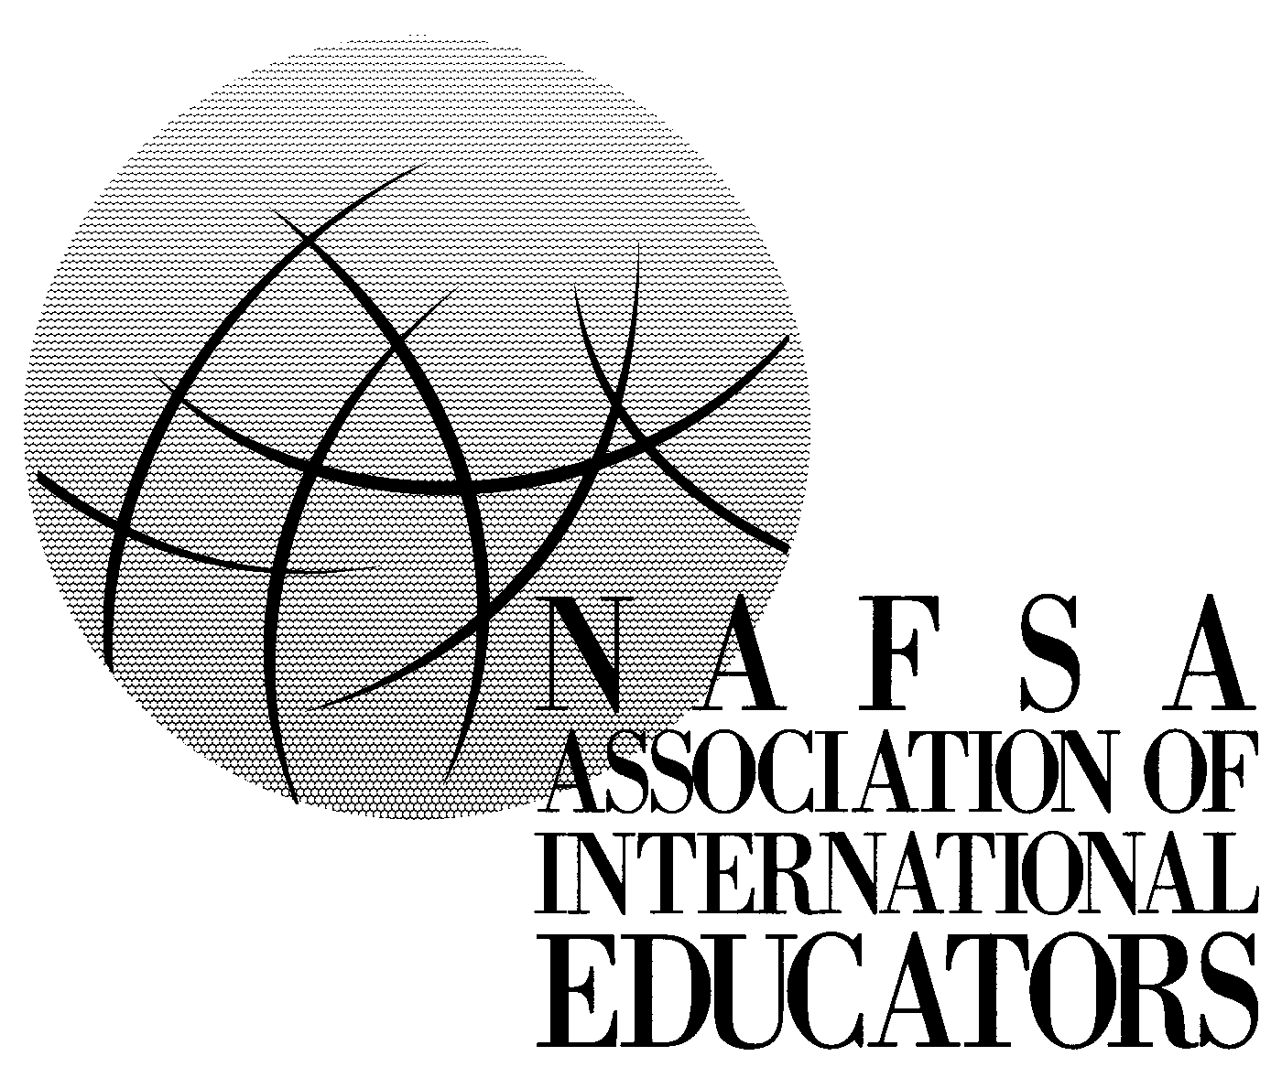

Travel Grant Application for a Regional Conference

Prescott Arizona 2007

Purpose: The purpose of this grant is to provide an opportunity for individuals working in Region II as professionals or volunteers in the field of international education to attend a NAFSA conference. Applications are welcomed from all interest sections of NAFSA. Examples of those who would be eligible for regional grants are: community participants who receive minimal compensation for part of their work; part-time employees; or professionals and volunteers who are unable to attend a conference without financial assistance. Because of the limited funds available, only a small number of grants or partial grants will be awarded. Selection will be based on demonstration of need and the strength of the statement of objectives.

Eligibility: Applicant must reside or be employed in Region II.
Applicants may be from any of NAFSA’s interest sections
Applicants must be currently engaged in work, as paid staff or as a volunteer, with post-secondary foreign students, U.S. students abroad or another component of global education at an education institution or in a community-based organization.
Applicants must be Regular NAFSA members
Applicant must be attending a NAFSA regional conference for the first time
Applicants may apply for NAFSA membership concurrently with the travel grant application. No funds will be awarded until NAFSA membership is confirmed.

Grant application review will begin September 30, 2007. All grants will be awarded by October 15, 2007. Late submissions will be considered on a case by case basis.

Application Procedure: Please return the completed application, statement of objectives and recommendation to:

Cynthia Banks, Treasurer, Region II. Electronic copy is preferred at cbanks@australearn.org or send it to Cynthia Banks, Treasurer Region II, c/o AustraLearn 12050 N Pecos Street, Suite 320, Westminster, Colorado 80234. Fax 303-446-5955. Applicants will receive an email notice to confirm receipt of application. If an email notice is not received within a few days, please call Cynthia at 303-446-2214x103.

Conditions of Award: Recipients are expected to participate in the entire conference and to submit a report on the conference to the Region II Chair within two weeks of the conference. Report forms will be sent to grantees with notice of award.

Personal Information

Name

Title

Institution

Department

Address

Phone Fax E-mail

1. In connection with foreign students/US students abroad, are you:

[ ] employed full-time? [ ] employed part-time? [ ] a volunteer?

2. On a separate sheet of paper, give a statement about why you wish to attend this conference and the specific benefits you hope to derive for your office/organization (Statement of Objectives).

3. Secure a letter of recommendation from a representative of your community organization or academic institution. This letter should address how you are involved with educational exchange activities, how attendance at this conference would enhance your role, and what your financial need is.

4. Financial Request: The grant may only cover transportation to and from the conference site. Applicants should be able to pay expenses related to lodging, food, and conference registration.

Total Expenses:

ESTIMATED TRAVEL
If auto travel, _____________ miles @ $0.445 per mile = $______________
If air travel, ticket cost = $______________

ESTIMATED REGISTRATION and/or WORKSHOP FEES
Registration/Workshop costs = $______________

Total estimated expenses (full funding is not typical) = $______________

Please let us know how you estimate your other expense to be covered:
Institution to cover $_________
Personal funds to cover $________
Requested Grant $________

